ROAD SAFETY ENHANCEMENT THROUGH DATA-DRIVEN ANALYSIS

Abstract— In this project, we delve into the complexities of traffic accidents, exploring causes, severity factors, and future trends. Through extensive literature analysis and meta-studies, we identify crucial elements such as driver behavior, road conditions, vehicle attributes, and environmental impacts. Additionally, we investigate the potential of emerging technologies like driverless vehicles and smart transportation networks, alongside the effectiveness of regulations and public awareness campaigns. Emphasizing data-driven approaches, we propose using advanced statistical analysis, machine learning, and predictive models to create personalized alert systems. Our multidisciplinary framework advocates integrating technical innovations, regulatory reforms, and data-driven initiatives to significantly enhance road safety, aiding policymakers, and stakeholders in informed decision-making for safer roads.
Keywords— Road Traffic Accidents in India, Accident Analysis, Public Health.

Introduction

Road traffic accidents in India provide a significant danger to the country's general population both in terms of the number of lives lost and the amount of money lost. The whole economic losses resulting from traffic accidents in India are estimated by the Ministry of Road Transport and Highways (MoRTH) to be around 3% of the country's yearly GDP[1]. These losses impact not just the budget but also the social framework, impacting communities and families and frequently leaving a lasting psychological scar.

The Indian government has responded by putting in place a number of laws and programs designed to improve road safety. In an effort to promote more responsible driving, the Motor Vehicles (Amendment) Act 2019 [2] toughened the penalty for infractions on the road. But the high rates of traffic accidents continue to suggest that changing policies is not enough. To comprehend and lessen the fundamental causes of these mishaps, data-driven methods are desperately needed.

If we are going to be successful in lowering the accident rate and making roads safer, it's important to have a solid understanding of the factors that lead to accidents and the effects that they have. This study makes use of data analytics to conduct an in-depth analysis of vehicular accidents, and as part of that process, it incorporates findings from several datasets that span various parts of India.
Accurate comprehension of the factors leading to accidents and their consequences is crucial for the

formulation of effective safety measures[14]. This research leverages data analytics to perform a thorough analysis of vehicular accidents across India, integrating insights from multiple datasets. These datasets provide critical new perspectives on accident etiology, vehicle classification, fault attribution, and severity levels. Our study focuses on examining the impact of variables such as alcohol consumption, vehicle faults, driving behaviors, and severity indices on accident rates, aiming to inform the development of more impactful public policy interventions and preventive strategies. The data analysis process utilizes datasets containing information across various parameters, including state, year, type of accident, time of occurrence, fault types, alcohol involvement, and severity[15]. The insights, graphs, and output generated from this analysis are intended to be utilized constructively, offering valuable feedback to transportation agencies and helping to formulate models that could potentially reduce future accidents[3].

Moreover, this study aims to bridge the gap between academic research and practical application. By closely examining the data and trends associated with road accidents in India, we aim to contribute to the development of more effective road safety strategies and interventions. Ultimately, the goal is to leverage data-driven insights to create a safer road environment in India, reducing both the human and economic toll of road traffic accidents[4].

Literature Review
A series of research papers delve into the multifaceted realm of road accidents, offering diverse insights and analytical approaches. They collectively contribute to our understanding of road safety and the mitigation of accidents.

Mhetre and Thube's (2023) study analyzes road crash data from 2016 to 2020 on a National Highway in Maharashtra, India, highlighting the influence of COVID-19 lockdowns on road safety. According to their investigation, head-on crashes, losing control of the vehicle, and speeding were the main causes of accidents that happened on 2-lane straight highways with T-junctions[2]. According to the study, car collisions follow a specific time pattern, with a large percentage happening between noon and six o'clock, particularly during the summer. Significantly, fewer accidents occurred during the rigorous COVID-19 lockout, despite a rise in several crash categories in 2020, such as fatal accidents and right-angle crashes. This research highlights the necessity for context-specific traffic management measures and provides essential insights for improving road safety.

Singh's (2017) research on traffic accidents in India provides important new information: male deaths are greater in the 30- to 59-year-old age range, which is the most susceptible. It draws attention to the higher risk of accidents during inclement weather and peak working hours[1]. There is a notable disparity in the risk of death between states and cities, with certain areas considerably higher than the national average. This research is essential to comprehending regional and demographic differences in traffic safety because it lays the groundwork for focused actions.

The study conducted by Rabbani et al. (2021) on road traffic accident statistics in Peshawar, Pakistan, highlights the serious problem of vehicle accidents in developing nations, where 1.2 million people die in accidents every year. To build thorough models, their method comprised gathering, sifting, and displaying accident data[3]. The majority of incidents happen during the day and include people who have not had enough traffic instruction, especially those in the 30- to 45-year-old age range, according to key results. The behavior of this population calls for more research. Their creative application of visualization tools offers authorities insightful information that helps them create focused actions to improve road safety and lower accident rates.

The complexity of highway accident analysis is discussed by Mannering, Shankar, and Bhat (2016), who concentrate on unobserved variability brought on by missing data. Their research demonstrates how incomplete data may distort accident analysis, producing inaccurate estimates and forecasts. In order to address this problem, they critically examine a number of statistical techniques, highlighting the necessity for sophisticated approaches[4]. The accuracy of accident data analysis will be improved by this research, which will improve road safety actions and tactics in response to various influencing variables.

With an emphasis on Andhra Pradesh, Ponnaluri (2011) offers a perceptive study of road traffic accidents (RTCs) in India. His study emphasizes how road length, car registration, RTCs, and deaths have all increased significantly, highlighting how India's transportation environment is changing. While the number of fatalities per vehicle has decreased, Ponnaluri observes a notable rise in the number of deaths per population. Additionally, he finds important risk factors, such as the distribution of RTCs across urban and rural regions, the frequency of incidents close to important public locations, and the participation of young cars in fatal crashes[11]. One important conclusion is that driver error accounts for over 75% of collisions, with uncontrolled junctions accounting for a considerable fraction of these incidents. He suggests several preventative measures, such as creating a system to record traffic accidents, including safety into the design of roads, increasing capacity, and improving emergency response services. This study provides a thorough foundation for creating focused road safety initiatives and is especially pertinent to comprehending the risk variables linked to RTCs in India.

It is clear that our study benefits immensely from the thorough investigation and varied approaches used in earlier studies. These studies offer priceless insights into the many facets of traffic accidents, including demographic analysis, safety measure effectiveness, and causal variables. We are better prepared to use data analytics to examine the complicated nature of traffic accidents in India by including these many viewpoints into our research[5]. Our approach to data-driven analysis has been greatly influenced by the information gained from these efforts, which has improved our capacity to create individualized alarm systems and prediction models. This literature analysis ensures that our study's findings significantly contribute to the formation of policy by bridging the gap between theoretical research and practical application, solidifying our grasp of the topic[16].

About the data set:
The dataset, consisting of 138,031 rows and 42 columns, presents a comprehensive repository of information pertaining to documented accidents. The breadth and depth of the data suggests a rich reservoir of insights into diverse facets of these incidents.
The columns encapsulate various dimensions crucial for understanding and analyzing these accidents. The columns are separated on the basis of their types into 7 categories:[21]

- Identification and Timestamps:
ACCIDENT_NO: Unique identification for each accident.
ACCIDENT_DATE and ACCIDENT_TIME: Date and time of each accident, providing a temporal perspective.

- Accident Characteristics:
ACCIDENT_TYPE: Nature or type of the accident, offering insights into the incident's characteristics.
LIGHT_CONDITION: Illumination status during the accident (day/night), impacting visibility.
SPEED_ZONE: The speed limit in the area, potentially impacting the severity.

- Location and Geography:
LONGITUDE and LATITUDE: Geographic coordinates of the accidents.
LGA_NAME and STAT_DIV_NAME: Location-specific information, such as the Local Government Area and Statistical Division where the accidents occurred.

- Severity and Participants:
SEVERITY: Indicates the severity level of the accident.
TOTAL_PERSONS, INJ_OR_FATAL, FATALITY, SERIOUSINJURY, OTHERINJURY, NONINJURED: Counts of individuals involved and their injury statuses.

- Participant Demographics:
MALES, FEMALES: Counts of male and female individuals involved in the accidents.
YOUNG_DRIVER, OLD_DRIVER: Involvement of drivers from different age groups.

- Vehicle Related Details:
NO_OF_VEHICLES: Total count of vehicles involved in each accident.
HEAVYVEHICLE, PASSENGERVEHICLE, MOTORCYCLE, PUBLICVEHICLE: Counts of different vehicle types involved.

- Additional Categorizations:
ALCOHOL_RELATED, UNLICENCSED: Indicates whether alcohol was involved or if individuals were driving without a license.

The demographics of those involved, the specifics of each accident location, the severity of each crash, and the environmental and societal elements that may have contributed to it are all captured in this dataset. Insights gained from analyzing this data may help with traffic safety, law enforcement initiatives, and even city planning.

Problem Definition:

It is challenging to conduct an in-depth investigation of vehicular collisions due to the intricacy and multifaceted character of these events. The purpose of the study is to find out what factors contribute to the majority of accidents, as well as why they are more likely to take place on those specific days of the week and as a result of certain kinds of errors[17].

When everything has been said and done, it would be beneficial to know how various levels of crash severity and types of vehicles correlate with one another[18]. The following is an example of the kinds of inquiries that will be investigated across the course of this project.

How much of an impact does drinking alcohol have on the risk of getting into an accident on different days of the week?

When is it that the most accidents take place throughout the day?

Which types of faults most frequently result in mishaps?

Compared to smaller vehicles, do large trucks and buses cause more accidents?

Does the severity of accidents seem to have increased over the past several years?

PROPOSED APPROACH:
The rigorous cleansing of data and preprocessing of accident data will be the first steps in the execution of our project. In the next steps, we will apply a number of different machine learning models[20], including as decision trees, K-nearest neighbors, and clustering algorithms, in order to identify important elements that contribute to accidents. We are going to be able to successfully present our ideas by using data visualization. These findings will serve as the foundation for policies and targeted awareness programmers that are aimed at reducing accidents and making Indian roads safer, and they will be guided by data. [19] Our methodology includes a comprehensive investigation of accident data, a model-driven analysis, and a proactive strategy to alleviate road safety concerns for the benefit of all relevant stakeholders.

EXPLORING AND PRESENTING PRELIMINARY RESULTS:

Data Summary:

the preliminary analysis of our dataset indicates that accidents exhibit diverse severity levels. this data set under analysis is legally obtained and publicly accessible. it comprises over 138031 rows and encompasses 42 columns, reflecting a substantial volume of data. factors such as speed zones and accident types appear to influence the severity of incidents[6], with certain accidents displaying higher severity levels than others. a more comprehensive understanding of the dataset will be achieved through further correlation analysis, enabling the extraction of context-specific insights.

Data Preprocessing:
In the data preprocessing phase using RapidMiner (which we presented for our seminar in last class), we began by importing the provided road traffic accidents dataset. We performed essential tasks such as handling missing values, ensuring data consistency, and standardizing formats. Categorical variables were encoded for numerical analysis, and outliers were identified and addressed to maintain data integrity. Feature scaling techniques were applied to ensure fair comparison between variables[7]. Additionally, we conducted exploratory data analysis to understand data distributions and relationships. This preprocessing step ensures the dataset's readiness for advanced analytical methods, enabling us to draw meaningful insights and make informed decisions based on the processed, cleaned, and standardized data. We provided some snapshots for a clear understanding. Removing all 4 columns other than day of week as we are not using them for our analysis.

Data Set— [3]
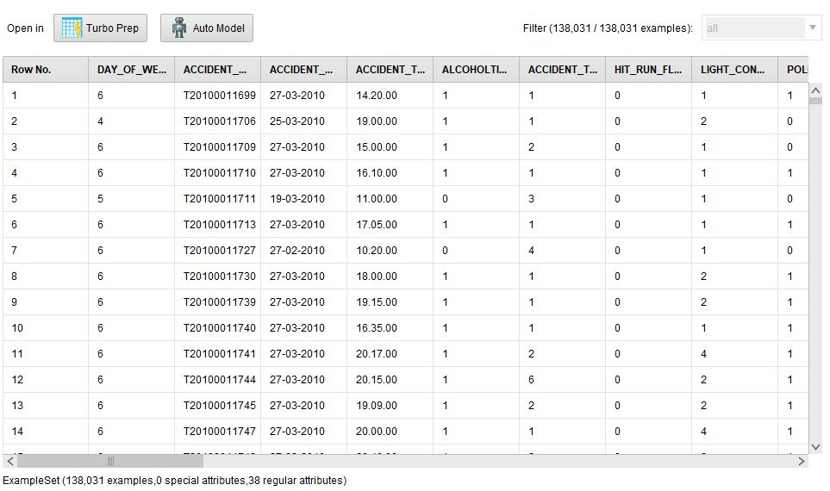
Figure-1 The Car Accident Data Set after Cleaning
The picture above shows Data was thoroughly cleaned for accuracy and analysis. To concentrate on vital information, four irrelevant columns were deleted. Then, duplicate rows were removed to avoid data redundancy. To standardize and compare dates, they were transformed. Numbers were assigned to categorical variables for numerical analysis. Last, missing values were imputed with the column median to minimize their impact on the analysis.

Descriptive Statistics:

The provided statistics and visualization depict the distribution of various accident types. Notably, road accidents account for 33.33% of the total incidents, with other railway accidents and rail-road accidents closely trailing at 30.89% each. Railway crossing and railway accidents are less frequent, making up 2.44% each. This data underscores the predominance of road-related accidents within the dataset, with other railway-related incidents being similarly significant.

Figure-2 DISTRIBUTION TYPE

Accident type distribution in a dataset is shown above. The majority of accidents are road accidents (33.33%). Other railway and rail-road accidents account for 30% of events. Fewer railway crossing and railway accidents occur, yet do happen. According to this data, road and railway accidents are the most common. This is likely owing to heavy road and rail traffic and a complicated driving environment.

Figure-3 Road Accidents Type

Visualizations & Preliminary Results:

- How much of an impact does drinking alcohol have on the risk of getting into an accident on different days of the week?
In our analysis, we assessed the impact of alcohol on road traffic accidents across different days of the week, with Monday represented as 1 till Sunday as 7. This approach allowed us to discern specific patterns in alcohol-related crashes concerning weekdays. By examining the dataset, we aimed to identify if there are days when alcohol-induced accidents are more prevalent. This investigation is crucial for understanding the correlation between alcohol consumption and accidents on different weekdays. These insights are invaluable for targeted interventions and formulating effective public safety policies. Our research contributes essential data to the ongoing dialogue on road safety, guiding initiatives to mitigate alcohol-related accidents and create safer roads for all.

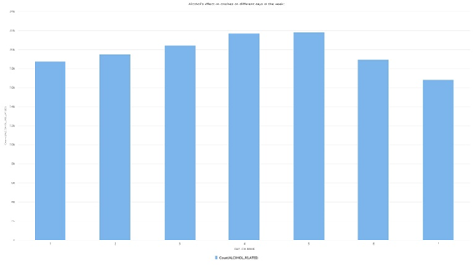

Figure-4 Alcohol Effects on crashes on different days

The pie chart visually represents the distribution of alcohol-related incidents throughout the week. It distinctly showcases a higher concentration of incidents on Fridays, amounting to 21,835, followed by Thursday with 21,212, Wednesday with 20,404, and Tuesday with 19,476. Notably, Sunday records the fewest incidents at 16,858. Overall, the chart emphasizes a pronounced spike in alcohol-related accidents during the end of the week, particularly on Fridays, gradually decreasing towards the start of the week, reaching its lowest on Sundays.

When is it that the most accidents take place throughout the day?

Figure-5 Accidents during a 3 hour interval

The graph shows the number of accidents in different time periods of the day. The highest number of accidents occurs between 6 and 9 AM, followed by 15 and 18 PM. The lowest number of accidents occurs between 12 and 15 PM. There are a few possible explanations for these patterns, including the increased volume of traffic during rush hour and driver fatigue. The graph does not show the rate of accidents, which would take into account the number of vehicles on the road at each time of day. Overall, the graph provides a useful overview of the number of accidents that occur at different times of day. This information can be used to identify times when the risk of accidents is highest and to develop strategies to reduce the number of accidents that occur.

Which types of faults most frequently result in mishaps?

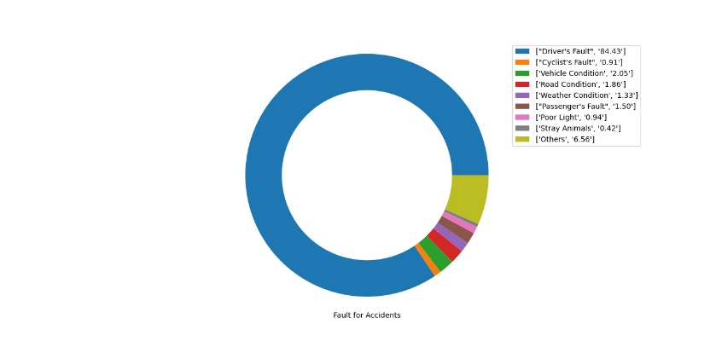
Figure-6 Fault for Accidents

According to the data, drivers are at blame for accidents over 80 percent of the time. Contrary to popular assumption, the fault does lay on the driver's shoulders in most circumstances. It's also worth remembering that things like wild animals, poor visibility, bad weather, and other environmental factors all play a role in these mishaps.

Compared to smaller vehicles, do large trucks and buses cause more accidents?

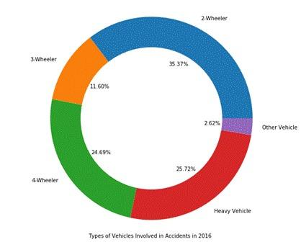
Figure-7 Vehicle Types
Several factors make two-wheelers more accident-prone. First, they're smaller and less visible to cars. Second, they offer less crash protection. Third, they're harder to steer than four-wheelers. Second in accidents are four-wheelers at 24.69%. As the most common car on the road, this is likely. Heavy trucks cause 25.72% of accidents, third. Heavy vehicles are more accident-prone due to their size and weight. Three-wheelers, bicycles, and walkers are less likely to crash yet susceptible. Three-wheelers are hard to see and manage, and cyclists and pedestrians encounter traffic.

Does the severity of accidents seem to have increased over the past several years?
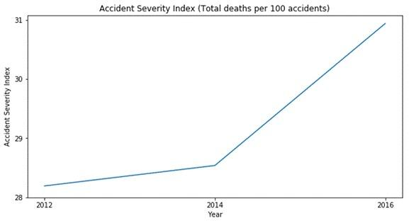
Accident severity is rising over time, as shown in the graph.
The insight helps create future models and emphasizes the necessity for appropriate ways to combat the rising severity trend.
MODEL BUILDING

DECISION TREE:
Decision trees are a kind of machine learning that can be used in accident data analysis. They recursively divide the dataset according to features such as time of day, weather, road type, speed zones, and more, which helps to determine the elements that contribute to accidents. The tree's nodes stand for features, and its branches represent decision rules that employ these features to arrive at leaf nodes that reflect projected outcomes, like accident severity or causes. Finding patterns and important characteristics that significantly affect accident severity or incidence is the main goal of using decision trees in accident data analysis. Stakeholders in the transportation and safety sectors can use these trees as a transparent and understandable model to better understand the causes that lead to accidents, so they can make data-driven decisions about infrastructure upgrades, targeted safety interventions, and prevention strategies.
Decision Tree analysis based on light conditions:

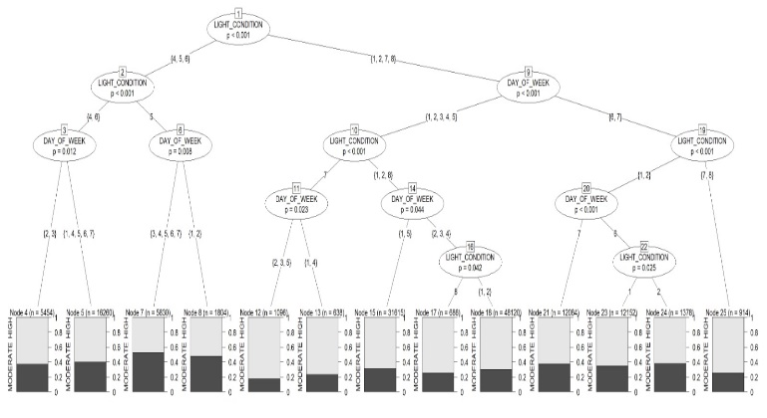

SELECTION OF BEST MODEL:

SPEED ZONE:

SEVERITY:
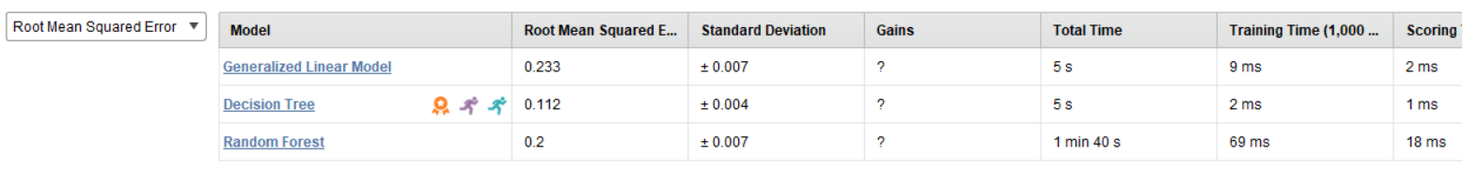
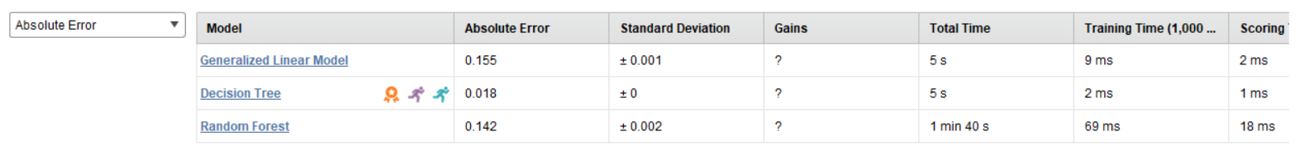
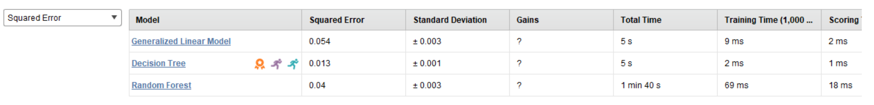

LIMITATIONS:
During our preliminary analysis of the road traffic accidents dataset, we encountered several limitations and challenges. One significant challenge was the presence of missing or incomplete data in some columns, which affected the accuracy of our analysis. Additionally, certain unexpected complexities within the dataset, such as inconsistencies in coding and variations in data formats, posed challenges during data preprocessing. We also noticed discrepancies in data quality, which required thorough cleaning and validation procedures[8]. Despite these challenges, we applied rigorous methods to address these issues, ensuring the reliability of our findings. However, it's crucial to acknowledge these limitations as they influenced the depth of our analysis and interpretations, underscoring the need for careful consideration in drawing conclusions from the dataset.

Project Scope:
Based on our extensive analysis using the dataset, we have gained invaluable insights into road accidents. Primarily, we discovered that most accidents are road-related, with driver fault being the predominant cause [9]. Through meticulous examination, we identified peak accident times and prevalent accident days, providing us with a detailed temporal understanding. Our analysis further involves advanced techniques such as decision tree modeling, which will enable us to predict accident patterns effectively. With access to this comprehensive dataset, we are uniquely positioned to inform the government about various accident scenarios and fault types. By disseminating these insights, we aim to guide the implementation of targeted safety measures, thereby contributing significantly to public safety [10]. Our goal is to bridge gaps in existing research by offering nuanced information, aiding in the formulation of evidence-based policies for accident prevention and road safety enhancement.

Future Analysis:
In our upcoming analysis, we plan to focus on overseeding data and other related accidents, broadening our scope to encompass various accident types [11]. By constructing intricate models, incorporating factors like location, timings, days, and specific faults, our goal is to predict the likelihood of accidents occurring. Leveraging the insights gathered from the project proposal and sample dataset, we aim to create robust predictive models. These models will not only enhance our understanding of accident patterns but also enable us to proactively identify high-risk scenarios [12]. By delving deeper into the data, we aspire to contribute significantly to accident prevention strategies, emphasizing a data-driven approach for a safer future on the roads [13].

References

- S. K. Singh, "Road Traffic Accidents in India: Issues and Challenges," in Transportation Research Procedia, vol. 25, pp. 4708-4719, 2017. [Online]. Available: https://doi.org/10.1016/j.trpro.2017.05.484

- K. V. Mhetre and A. D. Thube, "Statistical analysis of crash data and impact of COVID-19 on road crashes in Maharashtra, India," Journal of Engineering and Applied Sciences, vol. 70, no. 24, 2023. [Online]. Available:

https://doi.org/10.1186/s44147-023-00194-9

- M. B. A. Rabbani, M. A. Musarat, W. S. Alaloul, A. Maqsoom, H. Bukhari, and W. Rafiq, "Road Traffic Accident Data Analysis and Its Visualization," Civil Engineering and Architecture, vol. 9, no. 5, pp. 1603-1614, 2021. [Online]. Available: DOI: 10.13189/cea.2021.090530. https://www.hrpub.org/download/20210830/CEA30-14823813.pdf

- F. L. Mannering, V. Shankar, and C. R. Bhat, "Unobserved heterogeneity and the statistical analysis of highway accident data," in Analytic Methods in Accident Research, vol. 11, pp. 1-16, 2016. [Online]. Available: https://doi.org/10.1016/j.amar.2016.04.001

- J. J. Rolison, S. Regev, S. Moutari, and A. Feeney, "What are the factors that contribute to road accidents? An assessment of law enforcement views, ordinary drivers' opinions, and road accident records," in Accid Anal Prev, vol. 115, pp. 11–24, 2018. https://pubmed.ncbi.nlm.nih.gov/29529397/

- K. Masoumi, A. Forouzan, H. Barzegari, A. Asgari Darian, F. Rahim, B. Zohrevandi, and S. Nabi, "Effective factors in severity of traffic accident-related traumas; an epidemiologic study based on the Haddon matrix," Emerg (Tehran), vol. 4, pp. 78–82, 2016. [Online]. Available: https://www.ncbi.nlm.nih.gov/pmc/articles/PMC4893755/ [PMC free article] [PubMed] [Google Scholar]

- M. Swaroop, D. C. Straus, O. Agubuzu, T. J. Esposito, C. R. Schermer, and M. L. Crandall, "Pre-hospital transport times and survival for hypotensive patients with penetrating thoracic trauma," J Emerg Trauma Shock, vol. 6, pp. 16–20, 2013. [Online]. Available: [PMC free article] [PubMed] [Google Scholar]. https://www.scholars.northwestern.edu/en/publications/pre-hospital-transport-times-and-survival-for-hypotensive-patient

- A. Chandrasekharan, A. J. Nanavati, S. Prabhakar, and S. Prabhakar, "Factors impacting mortality in the pre-hospital period after road traffic accidents in urban India," Trauma Mon, vol. 21, 2016. [Online]. Available: [PMC free article] [PubMed] [Google Scholar]. https://www.mdpi.com/2071-1050/13/22/12467

- R. Dandona, G. A. Kumar, T. S. Raj, and L. Dandona, "Patterns of road traffic injuries in a vulnerable population in Hyderabad, India," Inj Prev, vol. 12, pp. 183–188, 2006. [Online]. Available: [PMC free article] [PubMed] [Google Scholar]. https://www.ncbi.nlm.nih.gov/pmc/articles/PMC2630936/

- S. Sonawane and M. Jambure, "Patterns of head injuries in road traffic accidents-an autopsy study," Int J Curr Res, vol. 7, pp. 23733–23737, 2015. [Online]. Available: https://doi.org/10.37506/ijfmt.v14i3.10363 [Google Scholar]

- R. V. Ponnaluri, "Road traffic crashes and risk groups in India: Analysis, interpretations, and prevention strategies," in IATSS Research, vol. 35, no. 2, pp. 104-110, 2012. [Online]. Available: https://doi.org/10.1016/j.iatssr.2011.09.002

- C. Panda, A. K. Dash, and D. Dash, "Assessment of Risk Factors of Road Traffic Accidents: A Panel Model Analysis of Several States in India," in Vision: The Journal of Business Perspective, SAGE Publishing, Aug. 1, 2022. [Online]. Available: https://doi.org/10.1177/09722629221113251

- M. M. Chong, "Traffic Accident Analysis Using Decision Trees and Neural Networks," arXiv.org, May 16, 2004. [Online]. Available: https://arxiv.org/abs/cs/0405050

- S. Krishnaveni and M. Hemalatha, "A Perspective Analysis of Traffic Accident using Data Mining Techniques," in International Journal of Computer Applications (IJCA). [Online]. Available: https://www.ijcaonline.org/archives/volume23/number7/2896-3788

- M. S. D. Ponmuthuramalingam, "Analyzing the Road Traffic and Accidents with Classification Techniques," in International Journal of Computer Trends and Technology (IJCTT). [Online]. Available: https://ijcttjournal.org/archives/ijctt-v5n4p135

- C. Panda, A. K. Dash, and D. P. Dash, "Assessment of Risk Factors of Road Traffic Accidents: A Panel Model Analysis of Several States in India," Vision, vol. 0, no. 0, 2022. [Online]. Available: https://doi.org/10.1177/09722629221113251
- A. Rajeev, S. B. Abraham, T. G. Reddy, C. M. Skariah, E. R. Indiradevi, and J. Abraham, "A community study of alcohol consumption in a rural area of South India," International Journal of Community Medicine and Public Health, vol. 4, no. 6, pp. 2172–2177, 2017. [Online]. Available: https://www.researchgate.net/publication/317117851_A_community_study_of_alcohol_consumption_in_a_rural_area_in_South_India

- World Bank, "The high toll of traffic injuries: Unacceptable and preventable," World Bank, 2017. [Online]. Available: https://openknowledge.worldbank.org/handle/10986/29129
- M. Peden, S. Richard, S. David, D. Mohan, A. A. Hyder, E. Jarawan, and C. Mathers, "World report on road traffic injury prevention," World Health Organization, 2004. [Online]. Available: https://www.who.int/publications-detail/world-report-on-road-traffic-injury-prevention
- OECD. (2018). Speed and crash risk. The International Transport Forum. https://www.itf-oecd.org/sites/default/files/docs/speed-crash-risk.pdf

- India Car Accidents 2005-2015. (2017, February Kaggle.https://www.kaggle.com/silicon99/dft-accident-data/

